**Bilgin AKSOY**

**2252286**

**Digital Image Processing Assigment-4 Report**

**Answer-1-a:**

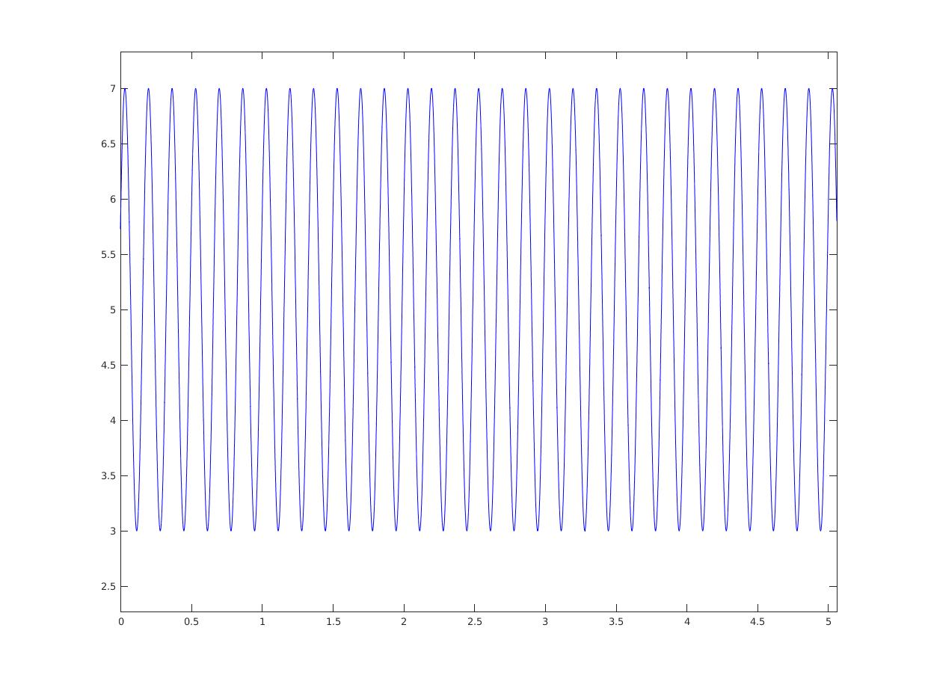

Phase=π/6

Amplitude=2

Period=5/(2*n)

Frequency=2*n/5

**Answer-1-b:**

Nyquist Rate= 2*(6/5*pi*n)/(2*pi)

**Answer-2-f:** I obtained the 180®rotated version of input image.

**Answer-3-c:** Normally two result must be same but I couldn’t find the problem with frequency domain filtering.

**Answer-4-b:** I found repaeated frequencies and assigned them to zero. But this time I loose the mean of the image and it has more low level intensities.

